**Transcript Stove Fire Tunnel Case**

Sometimes what happens that the gas of the stove on which we cook catches fire. So what we have done on the upside we have a exhaust system to which we have attached and installed the collapsable fire tunnel. This collapsable fire tunnel will be activated on the basis of the camera vision or infrared cameras if it detects a fire near the kitchen stove, thereby a motor will be actuated. This motor will activate the collapsable fire tunnel. Since it is a enclosed collapsable tunnel due to this the oxygen supply will be cut off and this will result in fire cut off or the enclosed collapsable tunnel will stop the fire due to lack of oxygen.

This collapsable fire tunnel will be integrated with the IoT (Internet of Things) that will ask on your mobile that are you cooking something because there is a fire on the gas stove. This IoT may use image processing or AI to detect and check whether it a actual fire or are you cooking something.

This collapsable fire tunnel may be used where we have some kind of fire hazards.

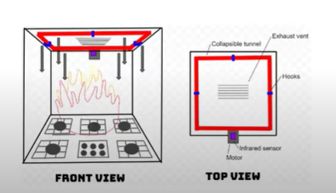

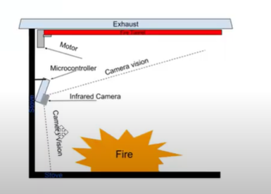

**Key Features**

**E1: Collapsible Boundary**

A hook powered by a trigger will unhook a collapsible boundary which will enclose the fire source.

**E2: Image Processing**

Detecting hazardous fire condition using image processing models or trained machine learning models.

**E3: IR Sensors**

Infrared cameras or heat sensors to detect fire hazard condition.

**E4: Warning system**

Upon detecting the fire hazard, the system notifies and asks user to confirm the detected fire hazard condition. (Feedback Loop).

**Note:** We have to work around the feature E4 and we have to add some more features like adding image processing techniques. Like how we are analysing that image by incorporating computer vision algorithm. ( is it a real cooking going on or it’s a kind of fire hazards). Then a notification or message will be sent to the user and the user will in return confirm if the form of feedback that whether it is normal fire or a hazardous fire i.e some kind of feedback system may be given by the user as well by using the mobile phone. Moreover we will try to generate the scenario to stop the false positives. Based on that feedback we can collapse the boundary of the tunnel as if required.

In the second video Faizan was proposing to add the feature of adding to spray carbon dioxide along with the collapsible fire tunnel to cut down the fire but that feature is already present in the prior art.